Contents

Logic Apps 2

Key terms 3

High throughput 4

Messaging System 4

Event Grid ( IFTT for Azure service & plugins) 4

Terminology 5

Azure Functions Vs Logic Apps Vs Even Grid 6

Event Hub ( Kafka ) 6

Key architecture components 7

Features and terminology in Azure Event Hubs 7

Namespace 7

Event Hubs for Apache Kafka 7

Event publishers 7

Publishing an event 7

Capture 8

SAS tokens 8

Consumer groups 8

Event Hub FAQs 8

Service Bus 9

Event vs. message services 10

Event 10

Message 10

Event Grid vs Event Hub vs Service Bus 10

Service Bus vs Storage Queue or Azure Queue 10

Suspend and reactivate messaging 13

Manage Session 13

First-in, first out (FIFO) pattern 13

Request-response pattern 14

Web App/ App Service 14

Limitations 14

App Service Plans 15

Pricing tier 15

How does my app run and scale? 16

How much does my App Service plan cost? 16

What if my app needs more capabilities or features? 17

Autoscaling 17

Custom Domain 20

Deployment Slots 21

WebJob 21

WebJob types 21

Azure CDN 23

Authenticate Web Apps 24

TLS mutual authentication or client certificate authentication 24

Choose the right integration and automation services in Azure 25

Azure Functions 26

What are Durable Functions? 26

Deployment Slots 27

How much does Functions cost? 27

Consumption plan 27

Premium plan 28

Dedicated (App Service) plan 28

Azure Functions networking 28

Always On 29

Cold Start 29

Storage account requirements 30

Enabling Session/ARR Affinity 30

Notification Hub 32

SendGrid or Mailjet 33

Note:

Event Grid : words like event processing, integrated with Azure resources

Service Bus: Message,

Event Hub : big data analytics

Logic App : workflow , integrated with traditional applications like outlook , share point, slack etc

# Logic Apps

<https://docs.microsoft.com/en-us/azure/logic-apps/logic-apps-overview>

[Azure Logic Apps](https://azure.microsoft.com/services/logic-apps) is a cloud service that helps you schedule, automate, and orchestrate tasks, business processes, and [workflows](https://docs.microsoft.com/en-us/azure/logic-apps/logic-apps-overview#logic-app-concepts) when you need to integrate apps, data, systems, and services across enterprises or organizations.

Every logic app workflow starts with a trigger, which fires when a specific event happens, or when new available data meets specific criteria. Many triggers provided by the connectors in Logic Apps include basic scheduling capabilities so that you can set up how regularly your workloads run.

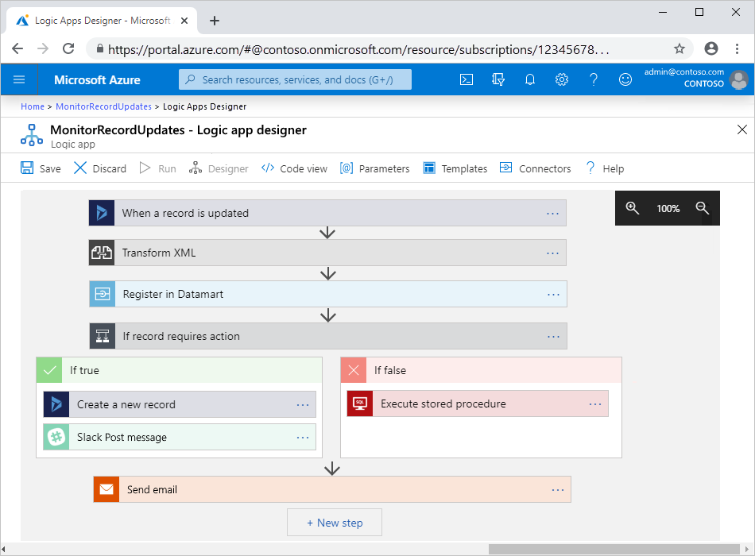

## Key terms

* **Workflow**: Visualize, design, build, automate, and deploy business processes as series of steps.
* **Managed connectors**: Your logic apps need access to data, services, and systems. You can use prebuilt Microsoft-managed connectors that are designed to connect, access, and work with your data. See [Connectors for Azure Logic Apps](https://docs.microsoft.com/en-us/azure/connectors/apis-list).
* **Triggers**: Many Microsoft-managed connectors provide triggers that fire when events or new data meet specified conditions. For example, an event might be getting an email or detecting changes in your Azure Storage account. Each time the trigger fires, the Logic Apps engine creates a new logic app instance that runs the workflow.
* **Actions**: Actions are all the steps that happen after the trigger. Each action usually maps to an operation that's defined by a managed connector, custom API, or custom connector.
* **Enterprise Integration Pack**: For more advanced integration scenarios, Logic Apps includes capabilities from BizTalk Server. The Enterprise Integration Pack provides connectors that help logic apps easily perform validation, transformation, and more.

<https://docs.microsoft.com/en-us/azure/logic-apps/quickstart-create-first-logic-app-workflow>

## High throughput

<https://docs.microsoft.com/en-us/azure/logic-apps/logic-apps-limits-and-config>

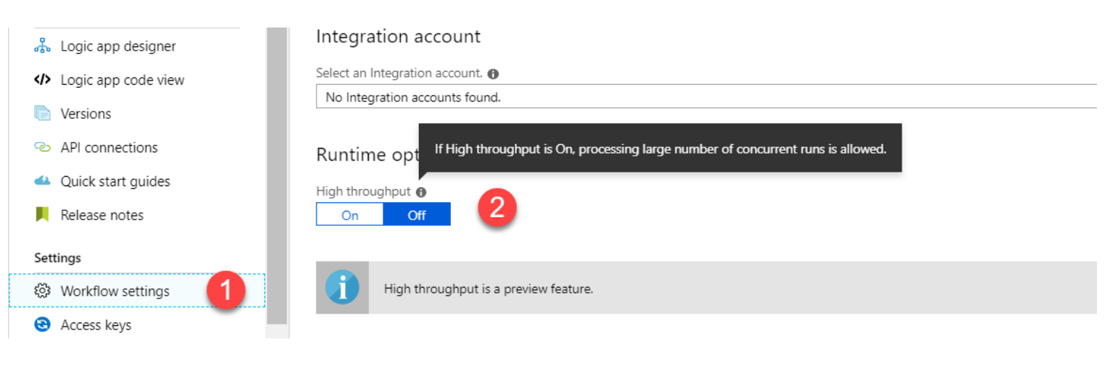

## Pricing

# Messaging System

Design consideration and patterns

<https://docs.microsoft.com/en-us/azure/architecture/guide/technology-choices/messaging>

1. Event Grid
2. Event Hub
3. Service Bus

<https://azure.microsoft.com/en-us/blog/events-data-points-and-messages-choosing-the-right-azure-messaging-service-for-your-data/>

# Event Grid (IFTT for Azure service & plugins)

<https://medium.com/microsoftazure/azure-event-grid-the-whole-story-4b7b4ec4ad23>

[Azure Event Grid](https://jlik.me/e1r) is a cloud service that provides infrastructure for event-driven computing. Event Grid focuses on **events** that declare, “something happened.”

Most Azure services automatically send messages through Event Grid and many can directly consume messages “out of the box.” Azure Event Grid supports a “push model.” In many cases it can also lead to cost savings because it removes the overhead of polling on a regular basis and instead triggers code only when it is needed to consume an event.

Here’s a list of the major key features of Azure Event Grid:

* Fully managed event routing service
* Built to support event-driven and serverless applications

### Terminology

There are several concepts that are useful to understand when working with Event Grid.

* **Events** — what happened (i.e. “file was uploaded” or “SKU was added”)
* **Event Publishers** — where the event happened (i.e. “web app” or “blob storage” or “CLI tool”)
* **Topics** — a channel for related events (i.e. “storage events” or “inventory events”)
* **Event Subscriptions** — how to receive events. A subscription informs Event Grid that an event should be routed to a handler. A single event can have multiple subscriptions, and subscriptions are named so they can be unsubscribed later if need be.
* **Event Handlers** — the app or service that receives and responds to the event (i.e. “Azure Function” or “Azure Logic App” or “my custom Ruby on Rails app”)

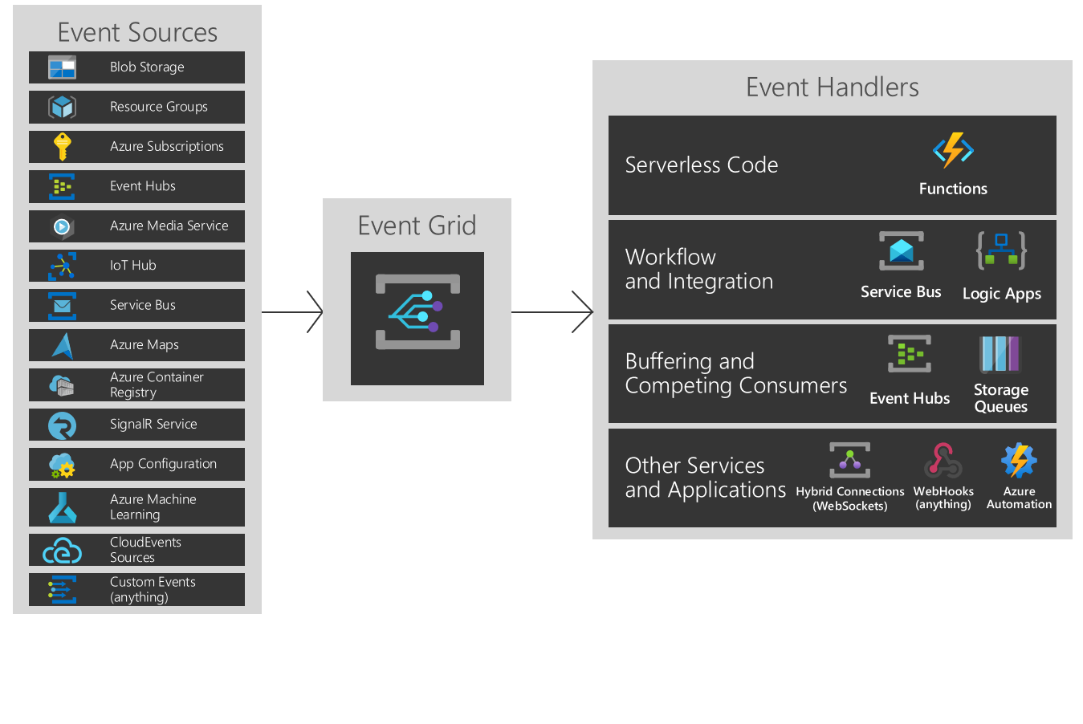

Event Grid supports dead-lettering for events that aren't delivered to an endpoint.

It has the following characteristics:

* dynamically scalable
* low cost
* serverless
* at least once delivery

### Azure Functions Vs Logic Apps Vs Even Grid

<https://tutorialsdojo.com/azure-functions-vs-logic-apps-vs-event-grid/>

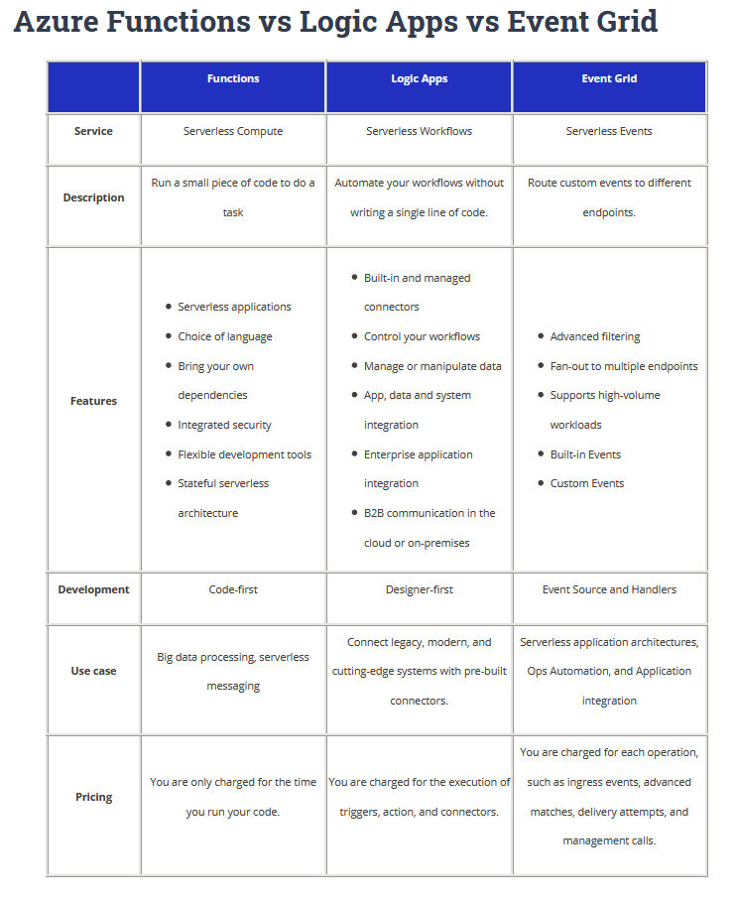

# Event Hub ( Kafka )

<https://docs.microsoft.com/en-us/azure/event-hubs/event-hubs-about>

Azure Event Hubs is a big data streaming platform and event ingestion service. It can receive and process millions of events per second.

The following scenarios are some of the scenarios where you can use Event Hubs:

* Anomaly detection (fraud/outliers)
* Application logging
* Analytics pipelines, such as clickstreams
* Live dashboarding
* Archiving data
* Transaction processing
* User telemetry processing
* Device telemetry streaming

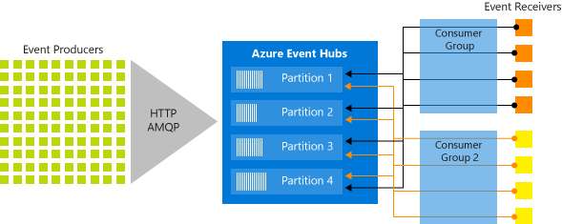

## Key architecture components

Event Hubs contains the following [key components](https://docs.microsoft.com/en-us/azure/event-hubs/event-hubs-features):

* **Event producers**: Any entity that sends data to an event hub. Event publishers can publish events using HTTPS or AMQP 1.0 or Apache Kafka (1.0 and above)
* **Partitions**: Each consumer only reads a specific subset, or partition, of the message stream.
* **Consumer groups**: A view (state, position, or offset) of an entire event hub. Consumer groups enable consuming applications to each have a separate view of the event stream. They read the stream independently at their own pace and with their own offsets.
* **Throughput units**: Pre-purchased units of capacity that control the throughput capacity of Event Hubs.
* **Event receivers**: Any entity that reads event data from an event hub. All Event Hubs consumers connect via the AMQP 1.0 session. The Event Hubs service delivers events through a session as they become available. All Kafka consumers connect via the Kafka protocol 1.0 and later.

## Features and terminology in Azure Event Hubs

<https://docs.microsoft.com/en-us/azure/event-hubs/event-hubs-features>

### Namespace

An Event Hubs namespace provides a unique scoping container, referenced by its [fully qualified domain name](https://en.wikipedia.org/wiki/Fully_qualified_domain_name), in which you create one or **more event hubs or Kafka topics**.

### Event Hubs for Apache Kafka

[This feature](https://docs.microsoft.com/en-us/azure/event-hubs/event-hubs-for-kafka-ecosystem-overview) provides an endpoint that enables customers to talk to Event Hubs using the Kafka protocol. This integration provides customers a Kafka endpoint. **Event Hubs for Apache Kafka supports Kafka protocol 1.0 and later.**

### Event publishers

Any entity that sends data to an event hub is an event producer, or event publisher. Event publishers can publish events using HTTPS or AMQP 1.0 or Kafka 1.0 and later. Event publishers use a Shared Access Signature (SAS) token to identify themselves to an event hub, and can have a unique identity, or use a common SAS token.

### Publishing an event

You can publish an event via AMQP 1.0, Kafka 1.0 (and later), or HTTPS. A single publication (event data instance) **has a limit of 1 MB**, regardless of whether it is a single event or a batch. Publishing events larger than this threshold results in an error. It is a best practice for publishers to be unaware of partitions within the event hub and to only specify a partition key (introduced in the next section), or their identity via their SAS token.

### Capture

[Event Hubs Capture](https://docs.microsoft.com/en-us/azure/event-hubs/event-hubs-capture-overview) enables you to automatically capture the streaming data in Event Hubs and save it to your choice of either a Blob storage account, or an Azure Data Lake Service account. You can enable Capture from the Azure portal, and specify a minimum size and time window to perform the capture.

### SAS tokens

Event Hubs uses Shared Access Signatures, which are available at the namespace and event hub level. A SAS token is generated from a SAS key and is a SHA hash of a URL, encoded in a specific format. Using the name of the key (policy) and the token, Event Hubs can regenerate the hash and thus authenticate the sender.

### Consumer groups

There can be at most 5 concurrent readers on a partition per consumer group; however **it is recommended that there is only one active receiver on a partition per consumer group**. Within a single partition, each reader receives all of the messages. If you have multiple readers on the same partition, then you process duplicate messages. You need to handle this in your code, which may not be trivial. However, it's a valid approach in some scenarios.

It has the following characteristics:

* low latency
* capable of receiving and processing millions of events per second
* at least once delivery

## Event Hub FAQs

<https://docs.microsoft.com/en-us/azure/event-hubs/event-hubs-faq>

1. When do I create a new namespace vs. use an existing namespace?

Capacity allocations ([throughput units (TUs)](https://docs.microsoft.com/en-us/azure/event-hubs/event-hubs-faq#throughput-units)) are billed at the namespace level. A namespace is also associated with a region.

You may want to create a new namespace instead of using an existing one in one of the following scenarios:

* You need an Event Hub associated with a new region.
* You need an Event Hub associated with a different subscription.
* You need an Event Hub with a distinct capacity allocation (that is, the capacity need for the namespace with the added event hub would exceed the 40 TU threshold and you don't want to go for the dedicated cluster)

1. What is the difference between Event Hubs Basic and Standard tiers?

The Standard tier of Azure Event Hubs provides features beyond what is available in the Basic tier. The following features are included with Standard:

Longer event retention

Additional brokered connections, with an overage charge for more than the number included

More than a single consumer group

Capture

Kafka integration

1. What is the maximum retention period for events?

Event Hubs Standard tier currently supports a maximum **retention period of seven days**.

1. How many partitions do I need?

The number of partitions is specified at creation and must be between 2 and 32. The partition count isn't changeable, so you should consider long-term scale when setting partition count.

# Service Bus

Microsoft Azure Service Bus is a fully managed enterprise integration message broker. Service Bus can decouple applications and services. Service Bus is intended for traditional enterprise applications. These enterprise applications require transactions, ordering, duplicate detection, and instantaneous consistency.

When handling high-value messages that cannot be lost or duplicated, use Azure Service Bus. Service Bus also facilitates highly secure communication across hybrid cloud solution

Data is transferred between different applications and services using **messages**. A message is in binary format and can contain JSON, XML, or just text.

**It has the following characteristics:**

* reliable asynchronous message delivery (enterprise messaging as a service) that requires polling
* advanced messaging features like FIFO, batching/sessions, transactions, dead-lettering, temporal control, routing and filtering, and duplicate detection
* at least once delivery
* optional in-order delivery

**Some common messaging scenarios are:**

Messaging. Transfer business data, such as sales or purchase orders, journals, or inventory movements.

* Decouple applications. Improve reliability and scalability of applications and services. Client and service don't have to be online at the same time.
* Topics and subscriptions. Enable 1:n relationships between publishers and subscribers.
* Message sessions. Implement workflows that require message ordering or message deferral.

## Event vs. message services

<https://docs.microsoft.com/en-us/azure/event-grid/compare-messaging-services>

There's an important distinction to note between services that deliver an event and services that deliver a message.

### Event

An event is a lightweight notification of a condition or a state change. The publisher of the event has no expectation about how the event is handled. The consumer of the event decides what to do with the notification. Events can be discrete units or part of a series.

The event data has information about what happened but doesn't have the data that triggered the event. The events are time-ordered and interrelated. The consumer needs the sequenced series of events to analyze what happened.

### Message

A message is raw data produced by a service to be consumed or stored elsewhere. The message contains the data that triggered the message pipeline. The publisher of the message has an expectation about how the consumer handles the message. A contract exists between the two sides. For example, the publisher sends a message with the raw data, and expects the consumer to create a file from that data and send a response when the work is done.

## Event Grid vs Event Hub vs Service Bus

|  |  |  |  |
| --- | --- | --- | --- |
| COMPARISON OF SERVICES | | | |
| Service | **Purpose** | **Type** | **When to use** |
| Event Grid | Reactive programming | Event distribution (discrete) | React to status changes |
| Event Hubs | Big data pipeline | Event streaming (series) | Telemetry and distributed data streaming |
| Service Bus | High-value enterprise messaging | Message | Order processing and financial transactions |

## Service Bus vs Storage Queue or Azure Queue

<https://docs.microsoft.com/en-us/azure/service-bus-messaging/service-bus-azure-and-service-bus-queues-compared-contrasted>

**Storage queues**, which are part of the Azure storage infrastructure, feature a simple REST-based GET/PUT/PEEK interface, providing reliable, persistent messaging within and between services.

As a solution architect/developer, **you should consider using Storage queues when**:

* Your application must **store over 80 GB of messages** in a queue.
* Your application wants to track progress for processing a message inside of the queue. This is useful if the worker processing a message crashes. **A subsequent worker can then use that information to continue from where the prior worker left off**.
* **You require server side logs of all of the transactions executed against your queues**.

As a solution architect/developer, **you should consider using Service Bus queues when**:

* Your solution must be able to receive messages without having to poll the queue. With Service Bus, this can be achieved through the use of the long-polling receive operation using the TCP-based protocols that Service Bus supports.
* Your solution requires the queue to provide a **guaranteed first-in-first-out (FIFO) ordered delivery**.
* Your solution must be able to support **automatic duplicate detection**.
* You want your application to process messages as parallel long-running streams (messages are associated with a stream using the [SessionId](https://docs.microsoft.com/en-us/dotnet/api/microsoft.servicebus.messaging.brokeredmessage.sessionid) property on the message). In this model, each node in the consuming application competes for streams, as opposed to messages. When a stream is given to a consuming node, the node can examine the state of the application stream state using transactions.
* Your solution requires transactional behavior and atomicity when sending or receiving multiple messages from a queue.
* Your application handles messages that can exceed 64 KB but will not likely approach the 256 KB limit.
* You deal with a requirement to provide a role-based access model to the queues, and different rights/permissions for senders and receivers. For more information, see the following articles:
  + [Authenticate with managed identities](https://docs.microsoft.com/en-us/azure/service-bus-messaging/service-bus-managed-service-identity)
  + [Authenticate from an application](https://docs.microsoft.com/en-us/azure/service-bus-messaging/authenticate-application)
* Your queue size will not grow larger than 80 GB.
* You want to use the AMQP 1.0 standards-based messaging protocol. For more information about AMQP, see [Service Bus AMQP Overview](https://docs.microsoft.com/en-us/azure/service-bus-messaging/service-bus-amqp-overview).
* You can envision an eventual migration from queue-based point-to-point communication to a message exchange pattern that enables seamless integration of additional receivers (subscribers), each of which receives independent copies of either some or all messages sent to the queue. The latter refers to the publish/subscribe capability natively provided by Service Bus.
* Your messaging solution must be able to support the "At-Most-Once" delivery guarantee without the need for you to build the additional infrastructure components.
* You would like to be able to publish and consume batches of messages.

|  |  |  |
| --- | --- | --- |
| **Comparison Criteria** | **Storage queues** | **Service Bus queues** |
| Ordering guarantee | **No**  For more information, see the first note in the “Additional Information” section. | **Yes - First-In-First-Out (FIFO)**  (through the use of messaging sessions) |
| Delivery guarantee | **At-Least-Once** | **At-Least-Once** (using PeekLock receive mode - this is the default)  **At-Most-Once** (using ReceiveAndDelete receive mode)  Learn more about various [Receive modes](https://docs.microsoft.com/en-us/azure/service-bus-messaging/service-bus-queues-topics-subscriptions#receive-modes) |
| Atomic operation support | **No** | **Yes** |
| Receive behavior | **Non-blocking**  (completes immediately if no new message is found) | **Blocking with/without timeout**  (offers long polling, or the ["Comet technique"](https://go.microsoft.com/fwlink/?LinkId=613759))  **Non-blocking**  (through the use of .NET managed API only) |
| Push-style API | **No** | **Yes**  [QueueClient.OnMessage](https://docs.microsoft.com/en-us/dotnet/api/microsoft.servicebus.messaging.queueclient.onmessage#Microsoft_ServiceBus_Messaging_QueueClient_OnMessage_System_Action_Microsoft_ServiceBus_Messaging_BrokeredMessage__) and [MessageSessionHandler.OnMessage](https://docs.microsoft.com/en-us/dotnet/api/microsoft.servicebus.messaging.messagesessionhandler.onmessage#Microsoft_ServiceBus_Messaging_MessageSessionHandler_OnMessage_Microsoft_ServiceBus_Messaging_MessageSession_Microsoft_ServiceBus_Messaging_BrokeredMessage__) sessions .NET API. |
| Receive mode | **Peek & Lease** | **Peek & Lock**  **Receive & Delete** |
| Exclusive access mode | **Lease-based** | **Lock-based** |
| Lease/Lock duration | **30 seconds (default)**  **7 days (maximum)** (You can renew or release a message lease using the [UpdateMessage](https://docs.microsoft.com/en-us/dotnet/api/microsoft.azure.storage.queue.cloudqueue.updatemessage) API.) | **60 seconds (default)**  You can renew a message lock using the [RenewLock](https://docs.microsoft.com/en-us/dotnet/api/microsoft.servicebus.messaging.brokeredmessage.renewlock#Microsoft_ServiceBus_Messaging_BrokeredMessage_RenewLock) API. |
| Lease/Lock precision | **Message level**  (each message can have a different timeout value, which you can then update as needed while processing the message, by using the [UpdateMessage](https://docs.microsoft.com/en-us/dotnet/api/microsoft.azure.storage.queue.cloudqueue.updatemessage) API) | **Queue level**  (each queue has a lock precision applied to all of its messages, but you can renew the lock using the [RenewLock](https://docs.microsoft.com/en-us/dotnet/api/microsoft.servicebus.messaging.brokeredmessage.renewlock#Microsoft_ServiceBus_Messaging_BrokeredMessage_RenewLock) API.) |
| Batched receive | **Yes**  (explicitly specifying message count when retrieving messages, up to a maximum of 32 messages) | **Yes**  (implicitly enabling a pre-fetch property or explicitly through the use of transactions) |
| Batched send | **No** | **Yes**  (through the use of transactions or client-side batching) |

## Suspend and reactivate messaging

<https://docs.microsoft.com/en-us/azure/service-bus-messaging/entity-suspend>

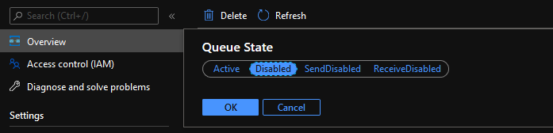

## Manage Session

<https://docs.microsoft.com/en-us/azure/service-bus-messaging/message-sessions>

Sessions can be used in **first in, first out (FIFO)** and **request-response** patterns.

### First-in, first out (FIFO) pattern

To realize a FIFO guarantee in Service Bus, use sessions.

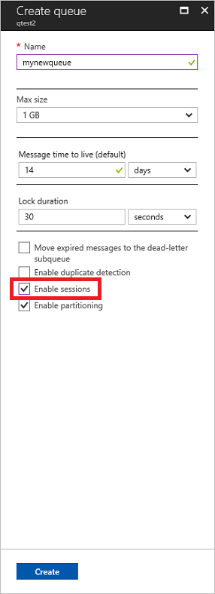

### Request-response pattern

The [request-reply pattern](https://www.enterpriseintegrationpatterns.com/patterns/messaging/RequestReply.html) is a well-established integration pattern that enables the sender application to send a request and provides a way for the receiver to correctly send a response back to the sender application. This pattern typically needs a short-lived queue or topic for the application to send responses to.

# Web App/ App Service

<https://docs.microsoft.com/en-us/azure/app-service/overview>

### Limitations

* App Service on Linux is not supported on [Shared](https://azure.microsoft.com/pricing/details/app-service/plans/) pricing tier.
* You can't mix Windows and Linux apps in the same App Service plan.
* Within the same resource group, you can't mix Windows and Linux apps in the same region.
* The Azure portal shows only features that currently work for Linux apps. As features are enabled, they're activated on the portal.
* When deployed to built-in images, your code and content are allocated a storage volume for web content, backed by Azure Storage. The disk latency of this volume is higher and more variable than the latency of the container filesystem. Apps that require heavy read-only access to content files may benefit from the custom container option, which places files in the container filesystem instead of on the content volume.

## App Service Plans

<https://docs.microsoft.com/en-us/azure/app-service/overview-hosting-plans>

In App Service (Web Apps, API Apps, or Mobile Apps), an app always runs in an App Service plan. In addition, [Azure Functions](https://docs.microsoft.com/en-us/azure/azure-functions/functions-scale#app-service-plan) also has the option of running in an App Service plan. An App Service plan defines a set of compute resources for a web app to run.

Each App Service plan defines:

* Region (West US, East US, etc.)
* Number of VM instances
* Size of VM instances (Small, Medium, Large)
* Pricing tier (Free, Shared, Basic, Standard, Premium, PremiumV2, Isolated)

### Pricing tier

<https://azure.microsoft.com/en-us/pricing/details/app-service/windows/>

The pricing tier of an App Service plan determines what App Service features you get and how much you pay for the plan. There are a few categories of pricing tiers:

* **Shared compute**: **Free** and **Shared**, the two base tiers, runs an app on the same Azure VM as other App Service apps, including apps of other customers. These tiers allocate CPU quotas to each app that runs on the shared resources, **and the resources cannot scale out.**
* **Dedicated compute**: The **Basic**, **Standard**, **Premium**, and **PremiumV2** tiers run apps on dedicated Azure VMs. **Only apps in the same App Service plan share the same compute resources. The higher the tier, the more VM instances are available to you for scale-out.**
* **Isolated**: This tier runs dedicated Azure VMs on **dedicated Azure Virtual Networks**. **It provides network isolation on top of compute isolation to your apps.** It provides the maximum scale-out capabilities.

Each tier also provides a specific subset of App Service features. These features include custom domains and TLS/SSL certificates, autoscaling, deployment slots, backups, Traffic Manager integration, and more. The higher the tier, the more features are available.

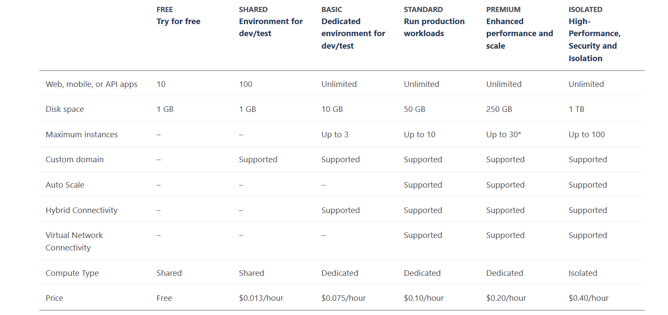

|  |  |  |  |  |  |  |  |
| --- | --- | --- | --- | --- | --- | --- | --- |
| Features | Free | Shared | Basic | Standard | Premium | Premium V2 | Isolated |
|  |  |  |  |  |  |  |  |
| Custom Domain |  |  |  |  |  |  |  |
| TLS |  |  |  |  |  |  |  |
| Auto Scale |  |  |  |  |  |  |  |
| VNet |  |  |  |  |  |  |  |
| Dedecated VNet |  |  |  |  |  |  |  |
|  |  |  |  |  |  |  |  |
|  |  |  |  |  |  |  |  |
|  |  |  |  |  |  |  |  |
|  |  |  |  |  |  |  |  |
| Backup |  |  |  |  |  |  |  |
| Deployment Slots |  |  |  |  |  |  |  |
|  |  |  |  |  |  |  |  |

## How does my app run and scale?

In the **Free** and **Shared** tiers, an app receives CPU minutes on a shared VM instance **and cannot scale out.** In other tiers, an app runs and scales as follows.

When you create an app in App Service, it is put into an App Service plan. **When the app runs, it runs on all the VM instances configured in the App Service plan.** If multiple apps are in the same App Service plan, they all share the same VM instances. If you have multiple deployment slots for an app, all deployment slots also run on the same VM instances. If you enable diagnostic logs, perform backups, or run WebJobs, they also use CPU cycles and memory on these VM instances.

In this way, the App Service plan is the scale unit of the App Service apps. **If the plan is configured to run five VM instances, then all apps in the plan run on all five instances.** If the plan is configured for autoscaling, then all apps in the plan are scaled out together based on the autoscale settings.

## How much does my App Service plan cost?

Except for **Free** tier, an App Service plan carries a charge on the compute resources it uses.

* In the **Shared** tier, each app receives a quota of CPU minutes, so each app is charged for the CPU quota.
* In the dedicated compute tiers (**Basic**, **Standard**, **Premium**, **PremiumV2**), the App Service plan defines the number of VM instances the apps are scaled to, so each VM instance in the App Service plan is charged. **These VM instances are charged the same regardless how many apps are running on them**.
* In the **Isolated** tier, the App Service Environment defines the number of isolated workers that run your apps**, and each worker is charged. In addition, there's a flat Stamp Fee for the running the App Service Environment itself.**

**You don't get charged for using the App Service features that are available to you (configuring custom domains, TLS/SSL certificates, deployment slots, backups, etc.).** The **exceptions** are:

* App Service Domains - you pay when you purchase one in Azure and when you renew it each year.
* App Service Certificates - you pay when you purchase one in Azure and when you renew it each year.
* IP-based TLS connections - There's an hourly charge for each IP-based TLS connection, but some **Standard** tier or above gives you one IP-based TLS connection for free. SNI-based TLS connections are free.

## What if my app needs more capabilities or features?

you can start testing your web app in a **Free** App Service plan and pay nothing. When you want to add your [custom DNS name](https://docs.microsoft.com/en-us/azure/app-service/app-service-web-tutorial-custom-domain) to the web app, just scale your plan up to **Shared** tier. Later, when you want to [create a TLS binding](https://docs.microsoft.com/en-us/azure/app-service/configure-ssl-bindings), **always on** scale your plan up to **Basic** tier. When you want to have [staging environments](https://docs.microsoft.com/en-us/azure/app-service/deploy-staging-slots), scale up to **Standard** tier along with **auto scaling, backup and Virtual Network**. When you need more cores, memory, or storage, scale up to a bigger VM size in the same tier.

**Isolate** your app into a new App Service plan when:

* The app is resource-intensive.
* You want to scale the app independently from the other apps in the existing plan.
* The app needs resource in a different geographical region.
* Wants dedicated VNet

## Autoscaling

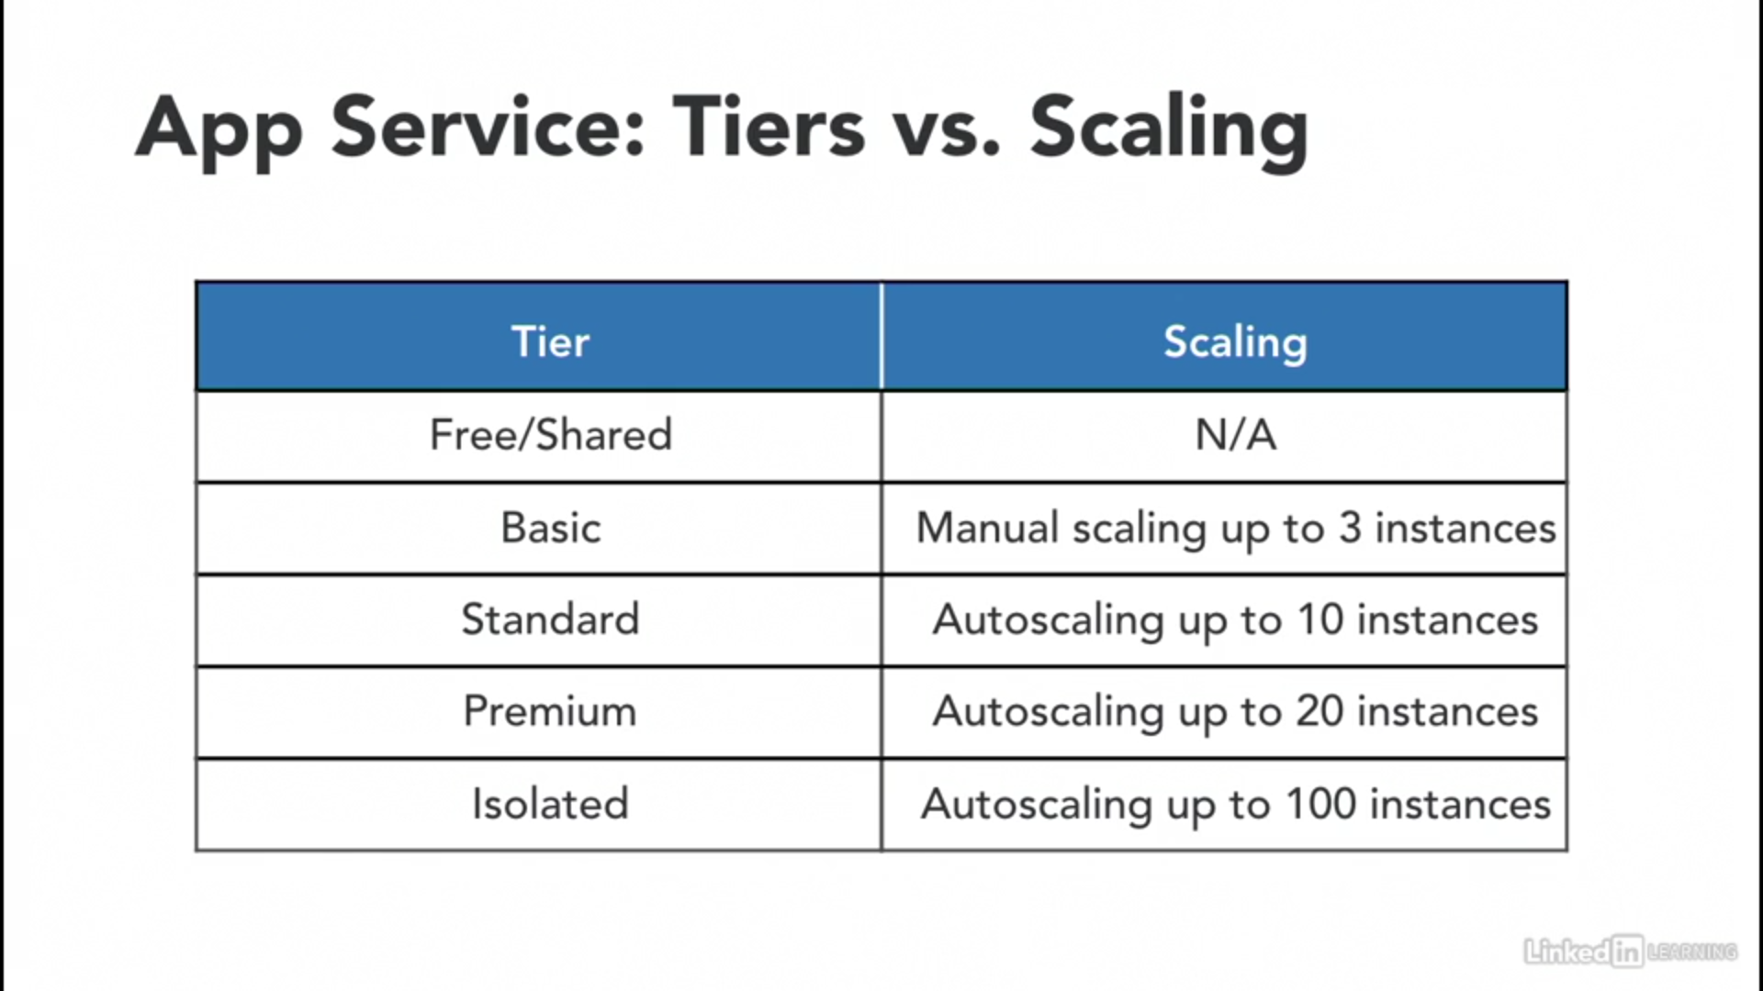

Scaling happen at App Service Plan level and hence apply to all instance of webapp part to that plan.

Also scaling happen on data collected by Azure Monitor metrices and hence various parameter can be chosen for scaling up or scaling out.

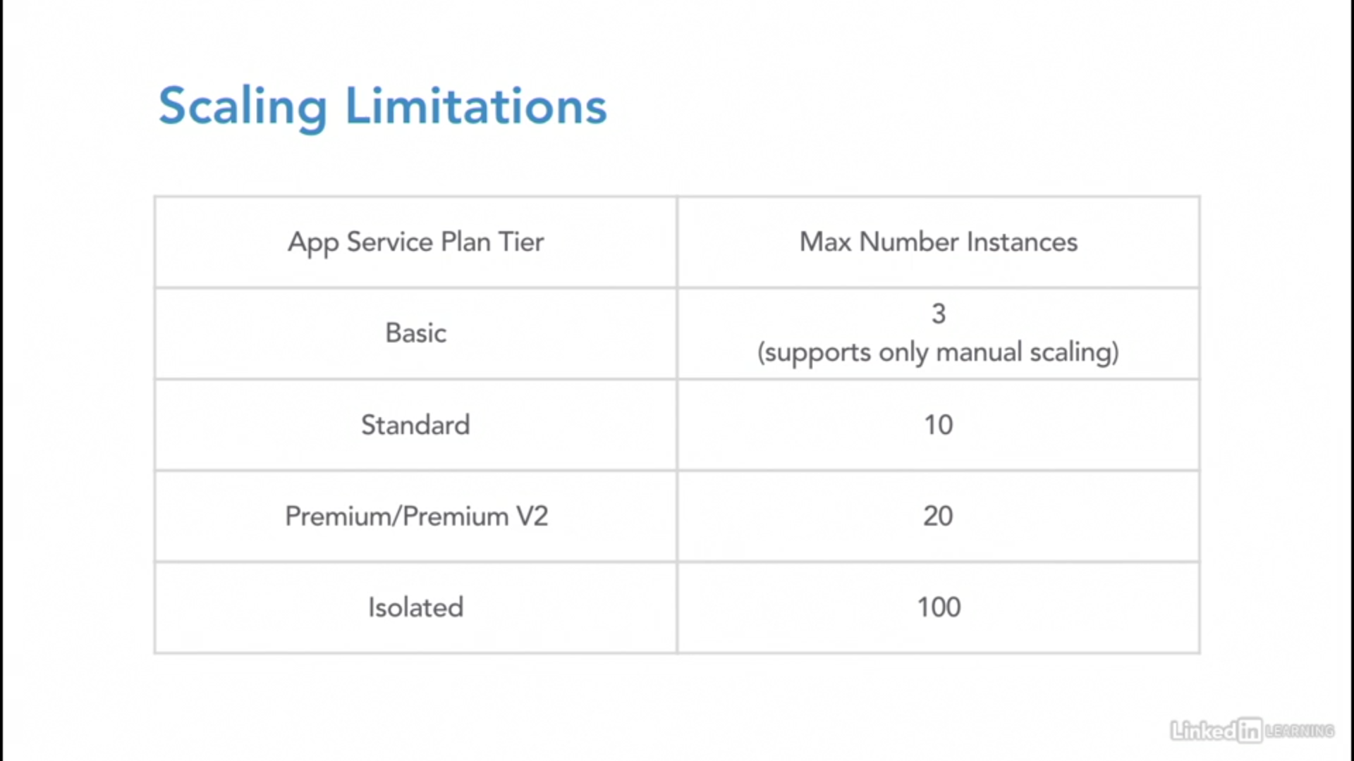

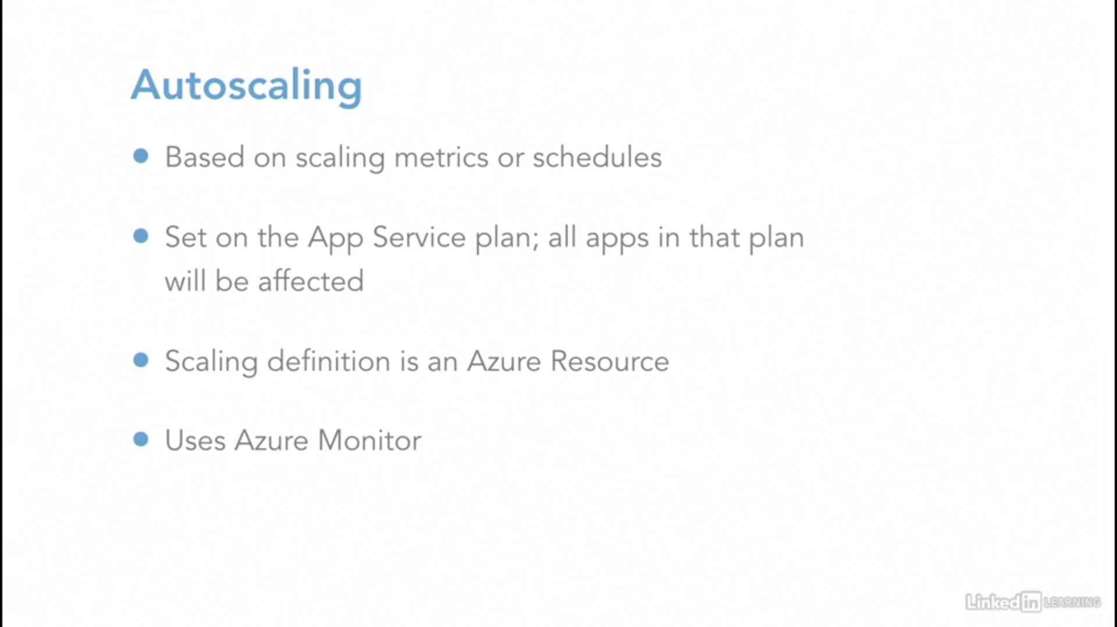

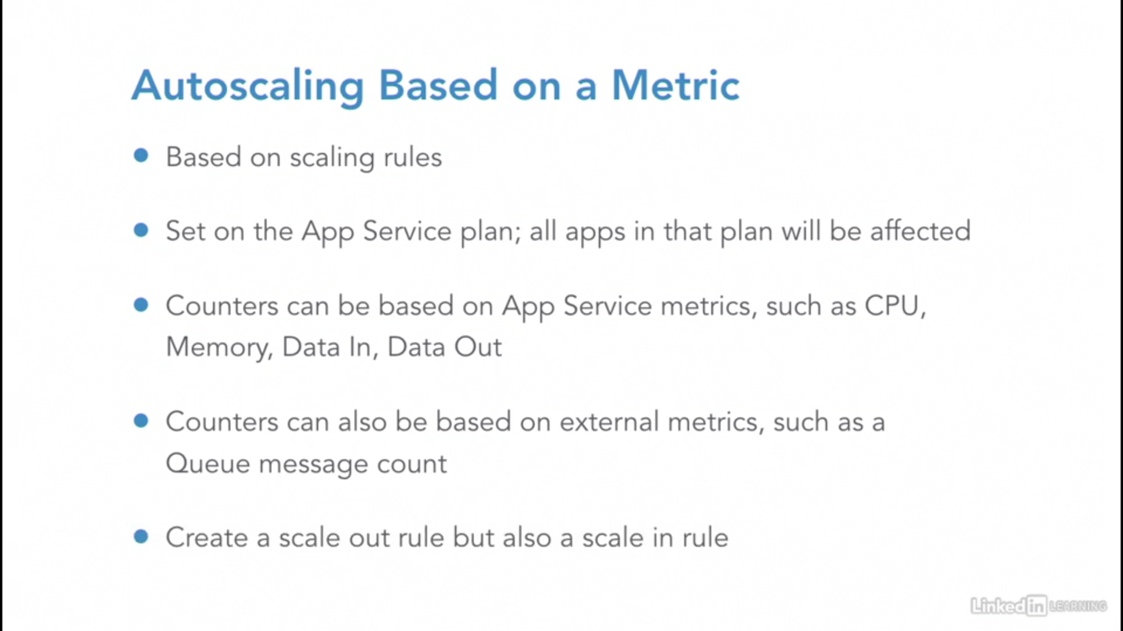

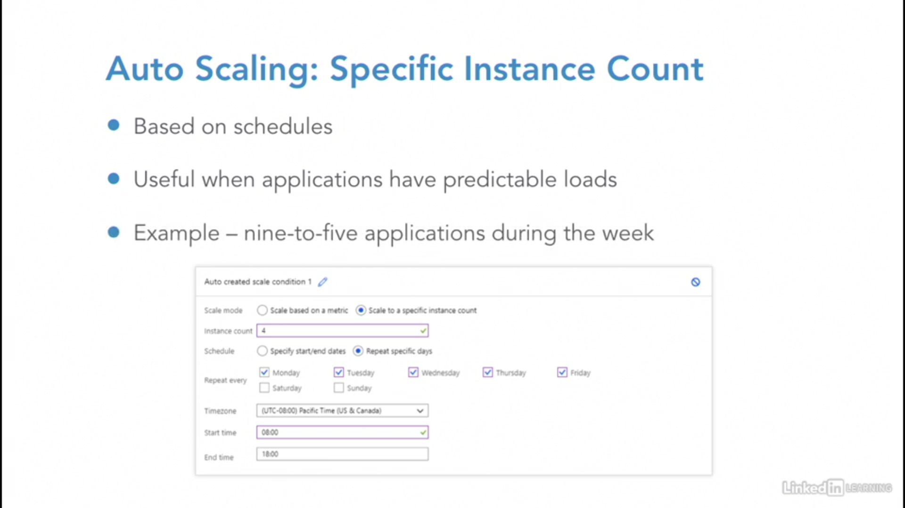

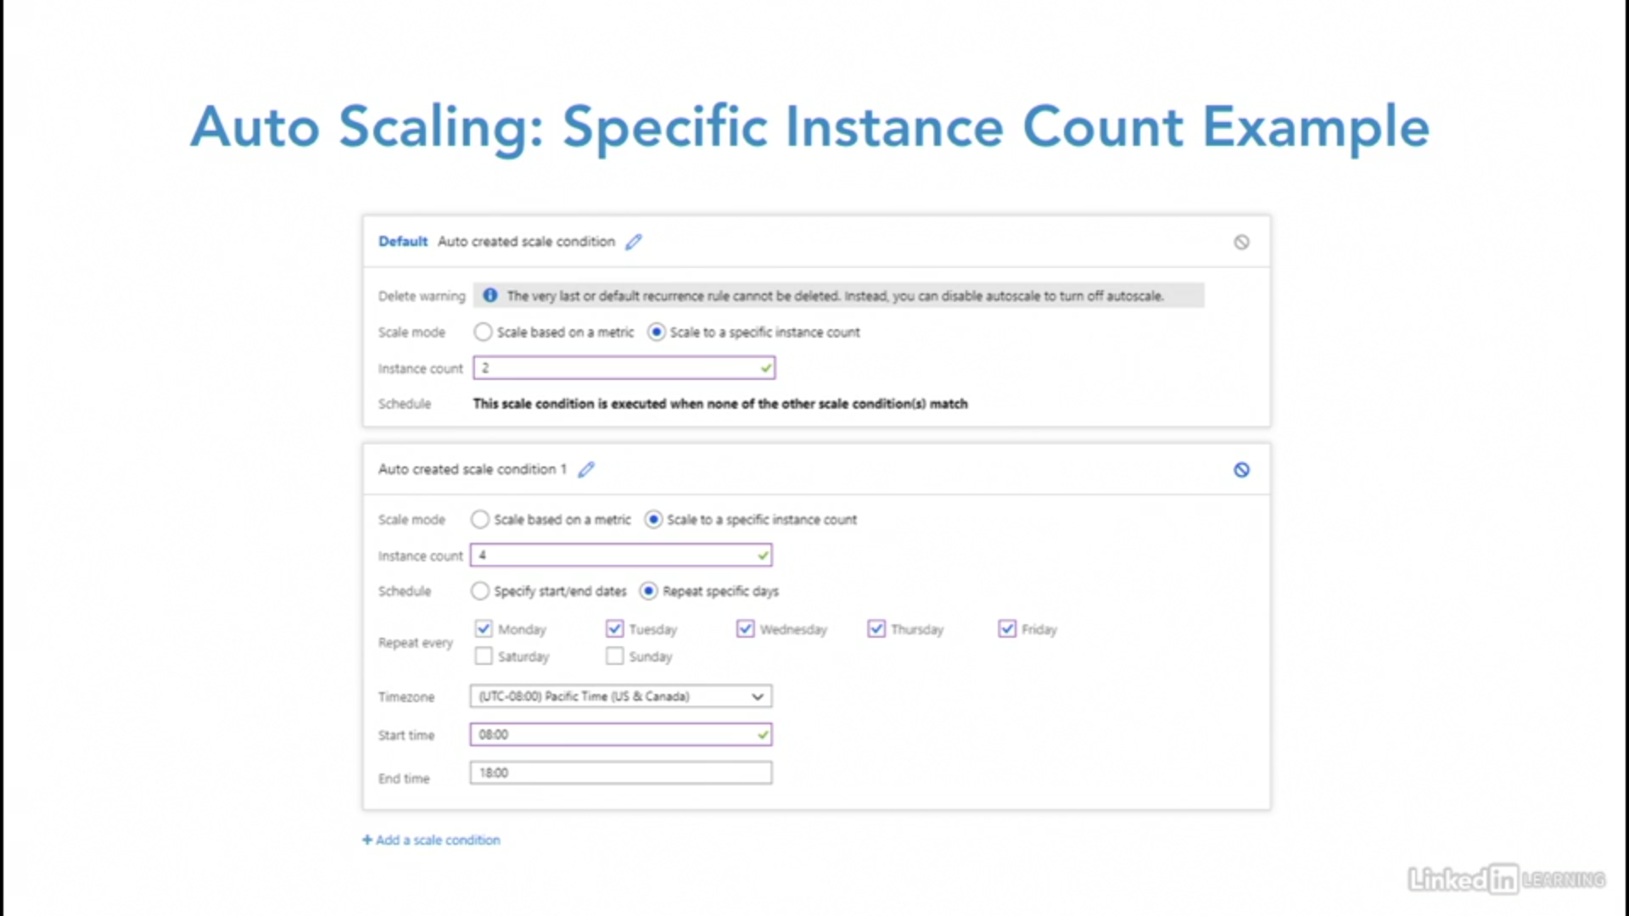

## Custom Domain

Can be done either using “A” records or “CNAME” records.

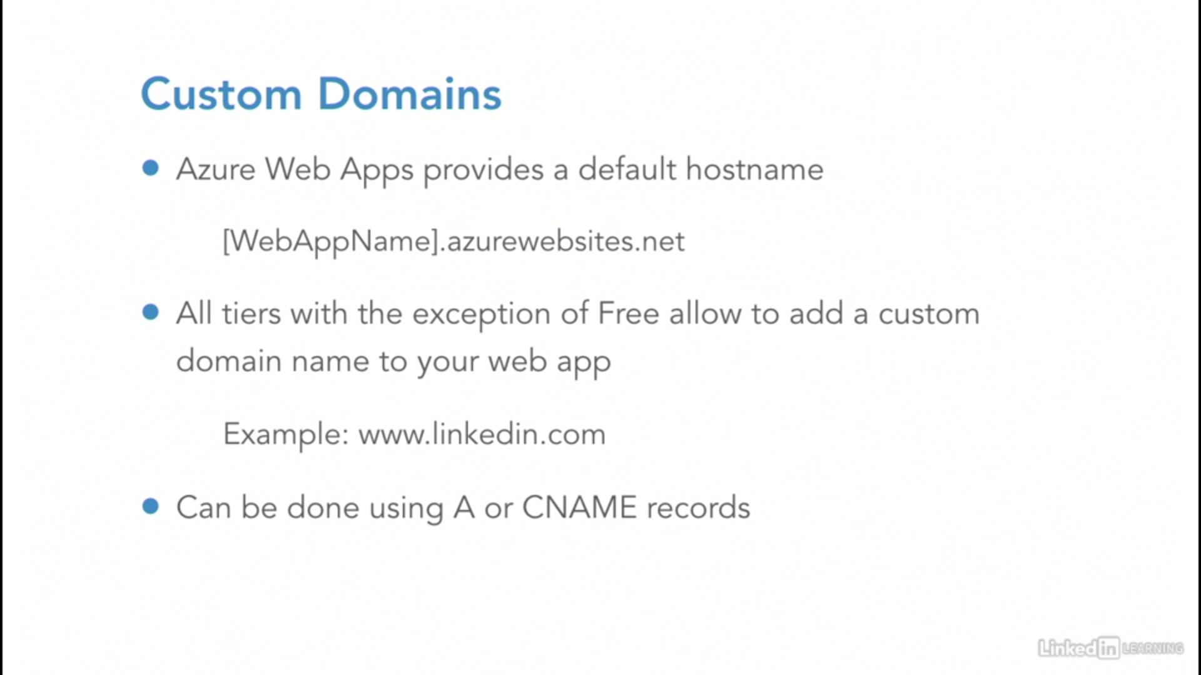

## Deployment Slots

<https://docs.microsoft.com/en-us/azure/app-service/deploy-staging-slots>

## WebJob

WebJobs is a feature of [Azure App Service](https://docs.microsoft.com/en-us/azure/app-service/) that enables you to run a program or script in the same instance as a web app, API app, or mobile app. **There is no additional cost to use WebJobs**.

**WebJobs is not yet supported for App Service on Linux.**

WebJobs and the WebJobs SDK work best together, but you can use WebJobs without the WebJobs SDK and vice versa. A WebJob can run any program or script that runs in the App Service sandbox.

<https://docs.microsoft.com/bs-latn-ba/azure/app-service/webjobs-create>

Creating a continuous Single-Instance WebJob is correct as this needs to be a continuous and a single instance, it is not recommended to use multi-instance to cleanup directories as they do the same job at the same time. The type should not be triggered as the requirement is continuous.

### WebJob types

The following table describes the differences between continuous and triggered WebJobs.

| WebJob types | |
| --- | --- |
| **Continuous** | **Triggered** |
| Starts immediately when the WebJob is created. To keep the job from ending, the program or script typically does its work inside an endless loop. If the job does end, you can restart it. | Starts only when triggered manually or on a schedule. |
| **Runs on all instances that the web app runs on. You can optionally restrict the WebJob to a single instance.** | **Runs on a single instance that Azure selects for load balancing.** |
| Supports remote debugging. | Doesn't support remote debugging. |

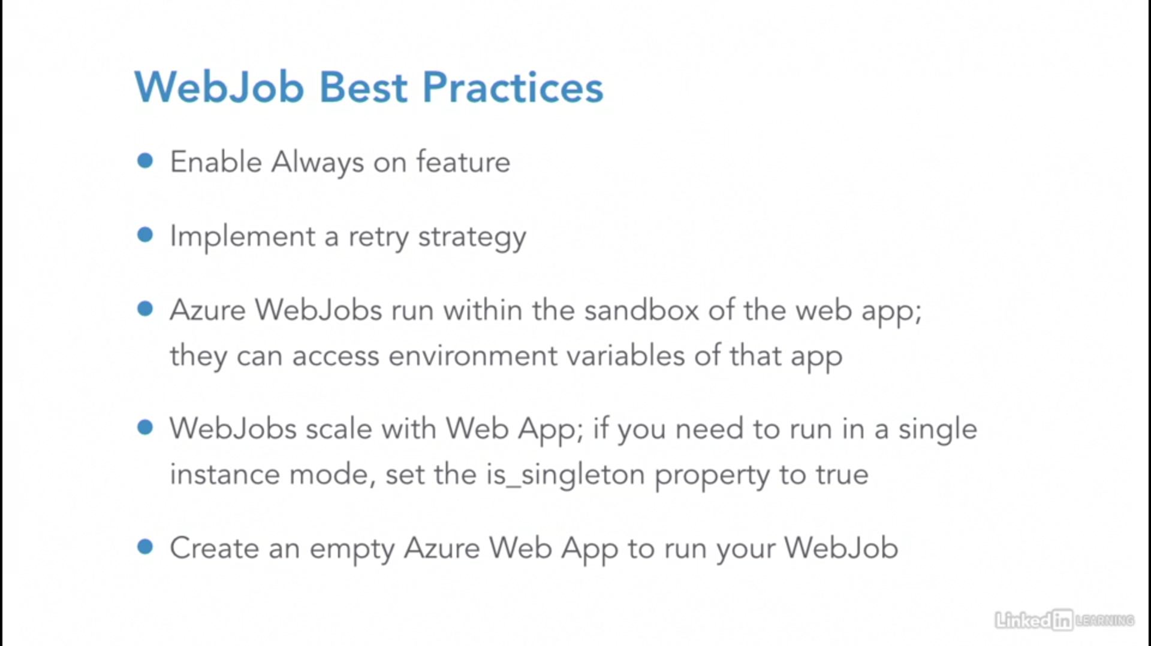

* Always On
* ARR Affinity
* Remote Debugging

## Azure CDN

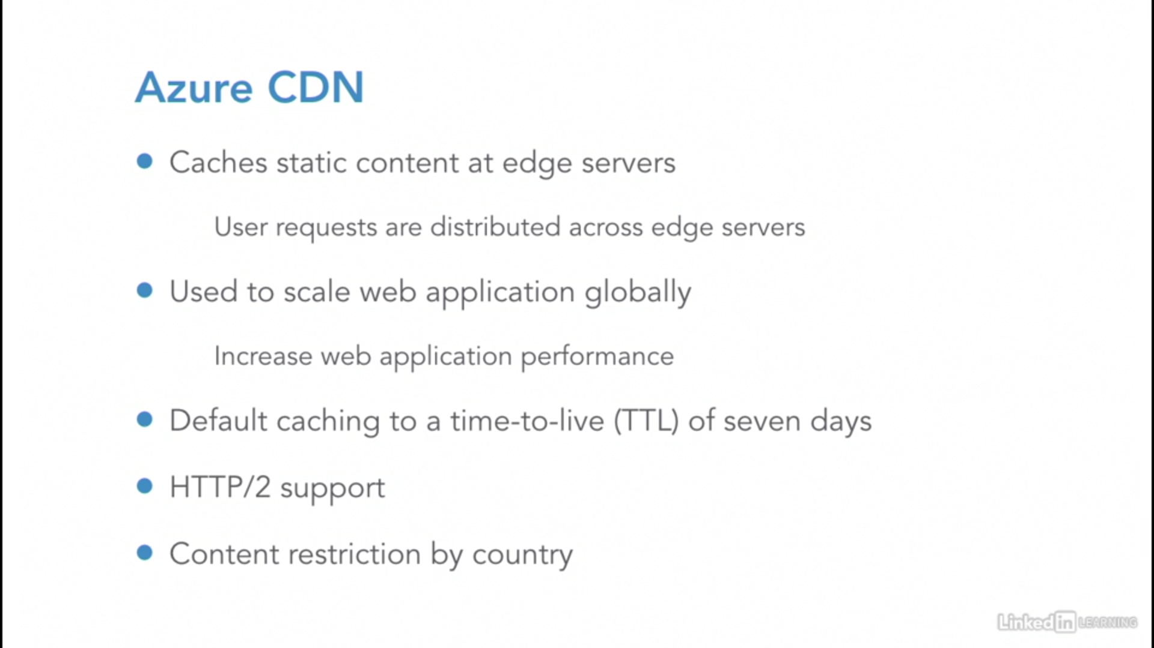

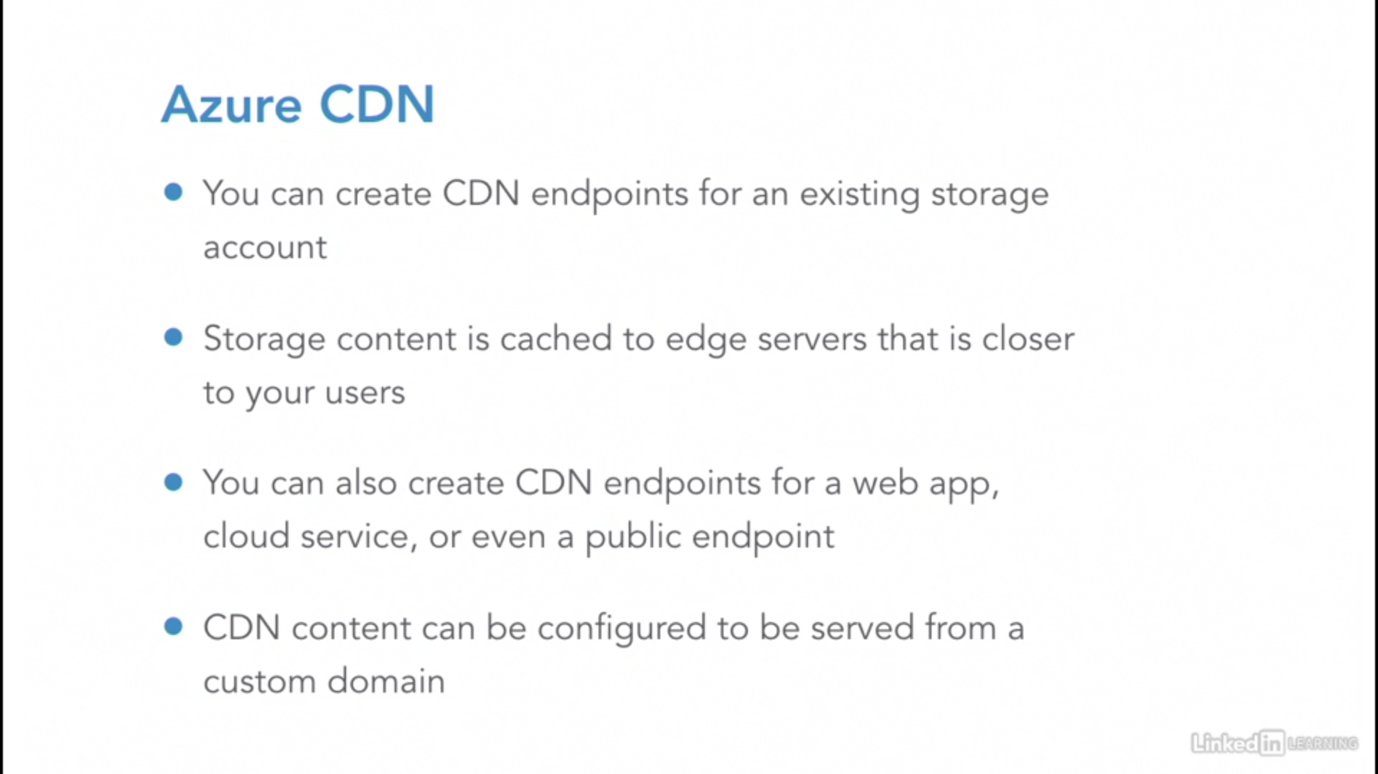

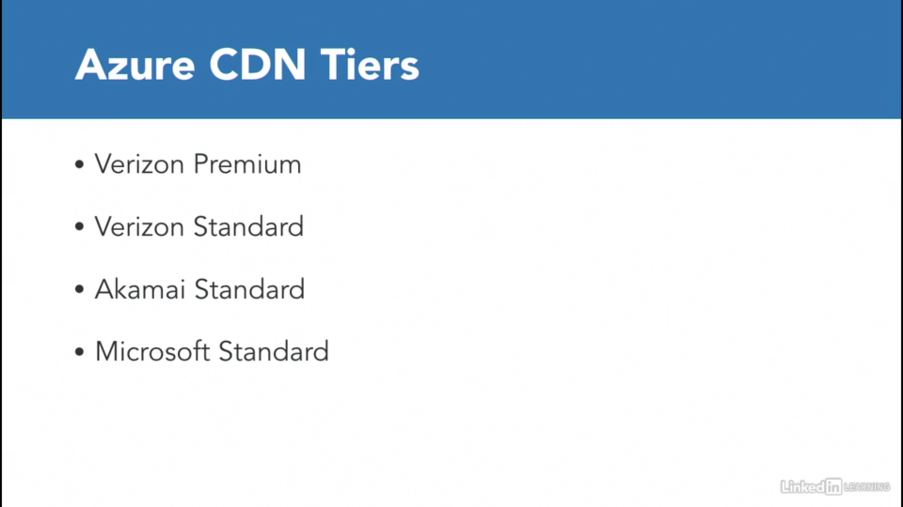

## Authenticate Web Apps

### TLS mutual authentication or client certificate authentication

<https://docs.microsoft.com/en-us/azure/app-service/app-service-web-configure-tls-mutual-auth>

You can restrict access to your Azure App Service app by enabling different types of authentication for it. One way to do it is to request a client certificate when the client request is over TLS/SSL and validate the certificate. This mechanism is called TLS mutual authentication or client certificate authentication.

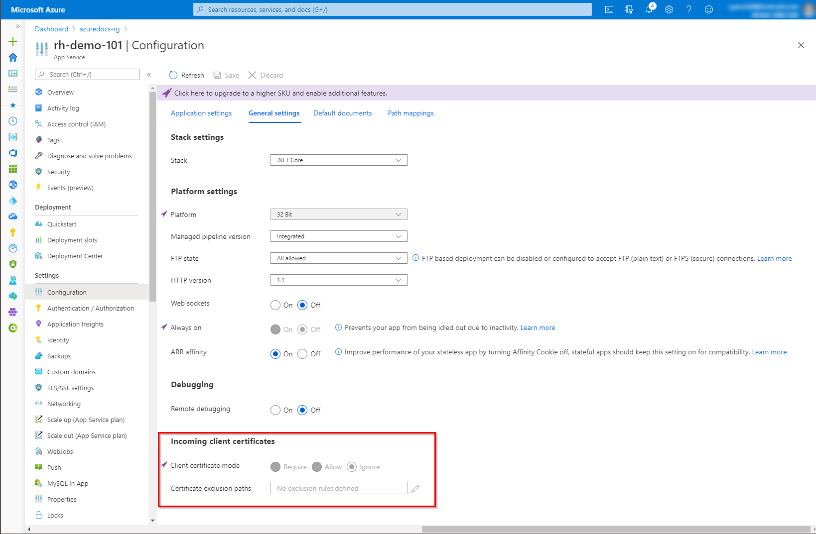

App Service injects an **X-ARR-ClientCert** **request header** with the client certificate. App Service does not do anything with this client certificate other than forwarding it to your app. Your app code is responsible for validating the client certificate.

For ASP.NET, the client certificate is available through the **HttpRequest.ClientCertificate** property.

For other application stacks (Node.js, PHP, etc.), the client cert is available in your app through a **base64 encoded** value in the **X-ARR-ClientCert request header**.

## Choose the right integration and automation services in Azure

<https://docs.microsoft.com/en-us/azure/azure-functions/functions-compare-logic-apps-ms-flow-webjobs>

<https://azure.microsoft.com/en-us/pricing/details/app-service/plans/>

Azure Functions offers more developer productivity than Azure App Service WebJobs does. **Azure Functions also offers more options for programming languages, development environments, Azure service integration, and pricing**

Here are two scenarios for which WebJobs may be the best choice:

* You need more control over the code that listens for events, the JobHost object. Functions offers a limited number of ways to customize JobHost behavior in the host.json file. Sometimes you need to do things that can't be specified by a string in a JSON file. For example, only the WebJobs SDK lets you configure a custom retry policy for Azure Storage.
* You have an App Service app for which you want to run code snippets, and you want to manage them together in the same Azure DevOps environment.

**For other scenarios where you want to run code snippets for integrating Azure or third-party services, choose Azure Functions over WebJobs with the WebJobs SDK.**

# Azure Functions

In Azure Functions, a function app provides the execution context for your individual functions. Function app behaviours apply to all functions hosted by a given function app. All functions in a function app must be of the same [language](https://docs.microsoft.com/en-us/azure/azure-functions/supported-languages).

***Like Azure Functions is the serverless evolution of Azure WebJobs, Durable Functions is the serverless evolution of the Durable Task Framework.***

|  | **Durable Functions** | **Logic Apps** |
| --- | --- | --- |
| **Development** | Code-first (imperative) | Designer-first (declarative) |
| **Connectivity** | [About a dozen built-in binding types](https://docs.microsoft.com/en-us/azure/azure-functions/functions-triggers-bindings#supported-bindings), write code for custom bindings | [Large collection of connectors](https://docs.microsoft.com/en-us/azure/connectors/apis-list), [Enterprise Integration Pack for B2B scenarios](https://docs.microsoft.com/en-us/azure/logic-apps/logic-apps-enterprise-integration-overview), [build custom connectors](https://docs.microsoft.com/en-us/azure/logic-apps/custom-connector-overview) |
| **Actions** | Each activity is an Azure function; write code for activity functions | [Large collection of ready-made actions](https://docs.microsoft.com/en-us/azure/logic-apps/logic-apps-workflow-actions-triggers) |
| **Monitoring** | [Azure Application Insights](https://docs.microsoft.com/en-us/azure/azure-monitor/app/app-insights-overview) | [Azure portal](https://docs.microsoft.com/en-us/azure/logic-apps/quickstart-create-first-logic-app-workflow), [Azure Monitor logs](https://docs.microsoft.com/en-us/azure/logic-apps/monitor-logic-apps) |
| **Management** | [REST API](https://docs.microsoft.com/en-us/azure/azure-functions/durable/durable-functions-http-api), [Visual Studio](https://docs.microsoft.com/en-us/visualstudio/azure/vs-azure-tools-resources-managing-with-cloud-explorer?view=vs-2019) | [Azure portal](https://docs.microsoft.com/en-us/azure/logic-apps/quickstart-create-first-logic-app-workflow), [REST API](https://docs.microsoft.com/en-us/rest/api/logic/), [PowerShell](https://docs.microsoft.com/en-us/powershell/module/az.logicapp), [Visual Studio](https://docs.microsoft.com/en-us/azure/logic-apps/manage-logic-apps-with-visual-studio) |
| **Execution context** | Can run [locally](https://docs.microsoft.com/en-us/azure/azure-functions/functions-runtime-overview) or in the cloud | Runs only in the cloud |

## What are Durable Functions?

<https://docs.microsoft.com/en-us/azure/azure-functions/durable/durable-functions-overview>

Durable Functions is an extension of [Azure Functions](https://docs.microsoft.com/en-us/azure/azure-functions/functions-overview) that lets you write stateful functions in a serverless compute environment. The extension lets you define stateful workflows by writing [orchestrator functions](https://docs.microsoft.com/en-us/azure/azure-functions/durable/durable-functions-orchestrations) and stateful entities by writing [entity functions](https://docs.microsoft.com/en-us/azure/azure-functions/durable/durable-functions-entities) using the Azure Functions programming model. Behind the scenes, the extension manages state, checkpoints, and restarts for you, allowing you to focus on your business logic.

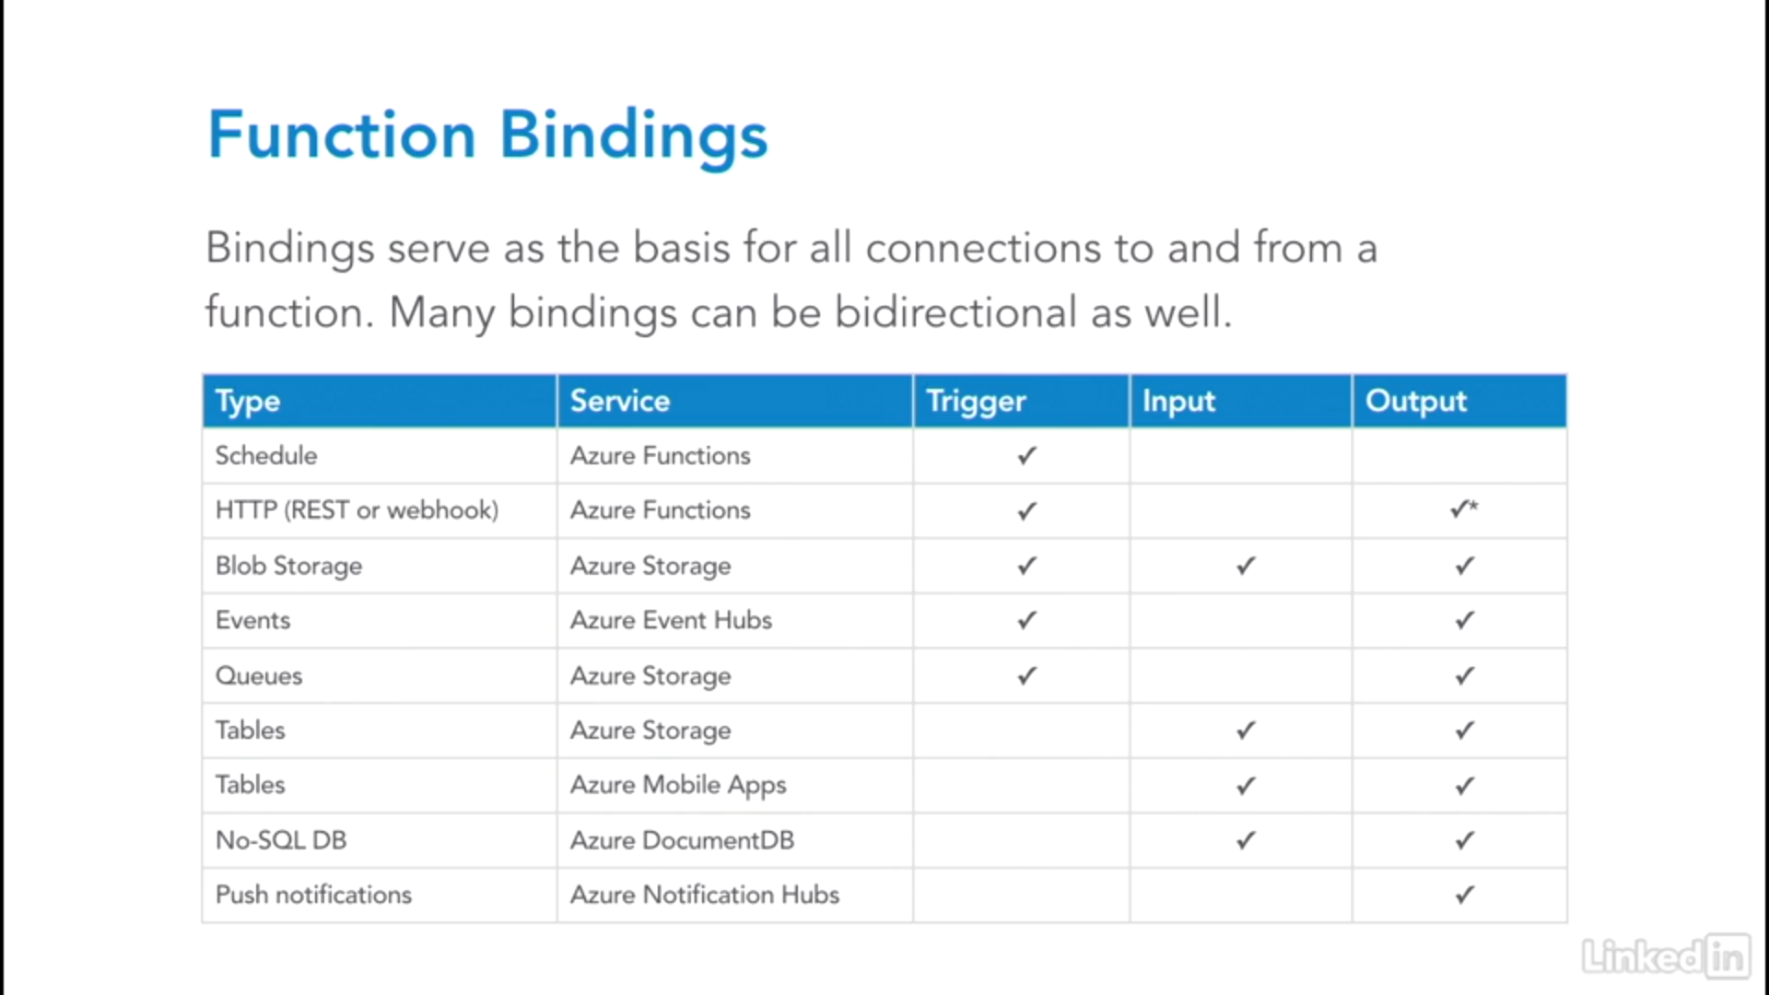

**Azure Function** has “**always on**” feature that keeps the app loaded even when there's no traffic. It's required for continuous WebJobs or for WebJobs that are triggered using a CRON expression.

It has Kudu Console to debug and see meta information

## Deployment Slots

<https://docs.microsoft.com/en-us/azure/azure-functions/functions-deployment-slots>

Slots are different environments exposed via a publicly available endpoint. One app instance is always mapped to the production slot, and you can swap instances assigned to a slot on demand. Function apps running under the **Apps Service plan may have multiple slots, while under the Consumption plan only one slot is allowed.**

**Slots are currently not available for the Linux Consumption plan.**

The following reflect how functions are affected by swapping slots:

* Traffic redirection is seamless; no requests are dropped because of a swap.
* If a function is running during a swap, execution continues, and the next triggers are routed to the swapped app instance.

## How much does Functions cost?

<https://docs.microsoft.com/en-us/azure/azure-functions/functions-scale>

Azure Functions has three kinds of pricing plans.

### Consumption plan

The Consumption plan is the default hosting plan and offers the following benefits:

* Pay only when your functions are running
* Scale out automatically, even during periods of high load

Function apps in the same region can be assigned to the same Consumption plan. There's no downside or impact to having multiple apps running in the same Consumption plan. Assigning multiple apps to the same Consumption plan has no impact on resilience, scalability, or reliability of each app.

### Premium plan

Premium plan supports the following features:

* Perpetually warm instances to avoid any cold start
* **VNet connectivity**
* Unlimited execution duration (60 minutes guaranteed)
* Premium instance sizes (one core, two core, and four core instances)
* More predictable pricing
* High-density app allocation for plans with multiple function apps

Consider the Azure Functions Premium plan in the following situations:

* **Your function apps run continuously, or nearly continuously.**
* You have a high number of small executions and have a high execution bill but low GB second bill in the Consumption plan.
* You need more CPU or memory options than what is provided by the Consumption plan.
* Your code needs to run longer than the [**maximum execution time allowed**](https://docs.microsoft.com/en-us/azure/azure-functions/functions-scale#timeout) on the Consumption plan.
* You require features that are only available on a Premium plan, such as **virtual network connectivity**.

### Dedicated (App Service) plan

Your function apps can also run on the same dedicated VMs as other **App Service apps (Basic, Standard, Premium, and Isolated SKUs).**

Consider an App Service plan in the following situations:

* You have existing, **underutilized VMs** that are already running other App Service instances.
* You want to provide a custom image on which to run your functions.

You pay the same for function apps in an App Service Plan as you would for other App Service resources, like web apps.

|  |  |  |  |
| --- | --- | --- | --- |
| Features | Consumption Plan | Premium Plan | App service Plan |
|  |  |  |  |
| Cold Start |  |  |  |
| Always On |  |  |  |
| Scale |  |  |  |
| VNet |  |  |  |
| Warm |  |  |  |
| Execution Duration |  |  |  |
|  |  |  |  |
|  |  |  |  |
|  |  |  |  |

## Azure Functions networking

<https://docs.microsoft.com/en-us/azure/azure-functions/functions-networking-options>

App service plan is Dedicated plan

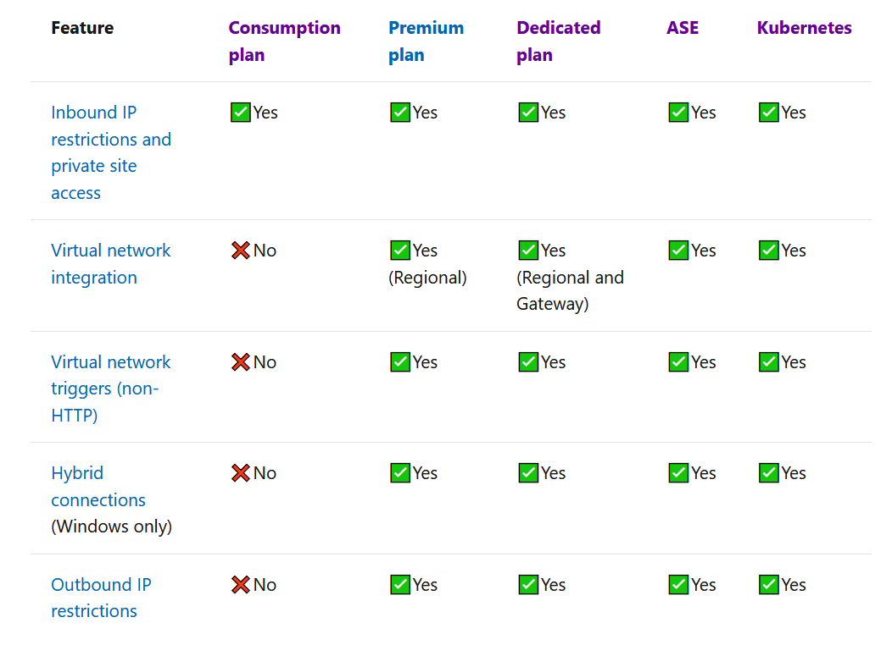

## Always On

If you run on an **App Service plan**, you should enable the **Always on** setting so that your function app runs correctly. On an App Service plan, the functions runtime goes idle after a few minutes of inactivity, so only HTTP triggers will "wake up" your functions. **Always on is available only on an App Service plan. On a Consumption plan, the platform activates function apps automatically.**

## Cold Start

After your function app has been idle for a number of minutes, the platform may scale the number of instances on which your app runs down to zero. **The next request has the added latency of scaling from zero to one.** This latency is referred to as a cold start. The number of dependencies that must be loaded by your function app can impact the cold start time. Cold start is more of an issue for synchronous operations, such as HTTP triggers that must return a response. **If cold starts are impacting your functions, consider running in a Premium plan or in a Dedicated plan with Always on enabled**.

## Storage account requirements

On any plan, **a function app requires a general Azure Storage account, which supports Azure Blob, Queue, Files, and Table storage.** This is because Azure Functions relies on Azure Storage for operations such as managing triggers and logging function executions, but some storage accounts don't support queues and tables. These accounts, which include blob-only storage accounts (including premium storage) and general-purpose storage accounts with zone-redundant storage replication, are filtered-out from your existing **Storage Account** selections when you create a function app.

**Function code files are stored on Azure Files shares** on the function's main storage account. When you delete the main storage account of the function app, the function code files are deleted and cannot be recovered.

## Enabling Session/ARR Affinity

<https://azure.microsoft.com/en-in/blog/disabling-arrs-instance-affinity-in-windows-azure-web-sites/>

<https://azure.github.io/AppService/2016/05/16/Disable-Session-affinity-cookie-(ARR-cookie)-for-Azure-web-apps.html>

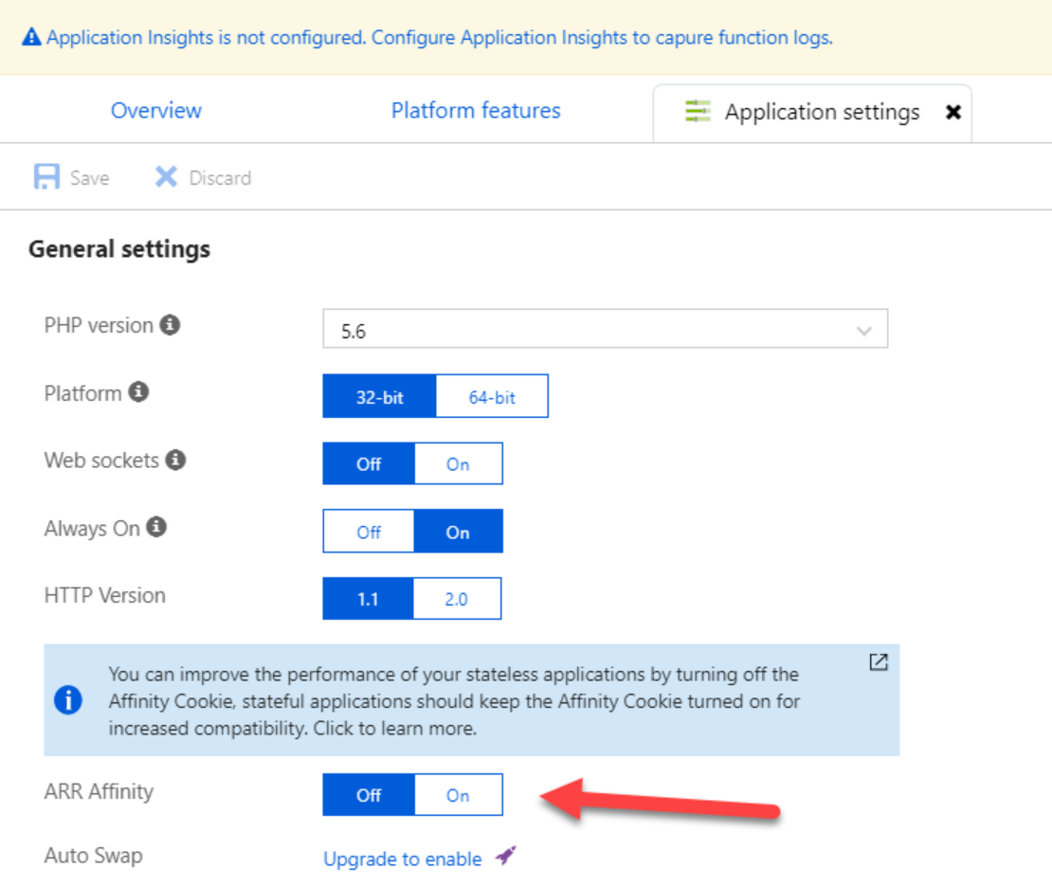

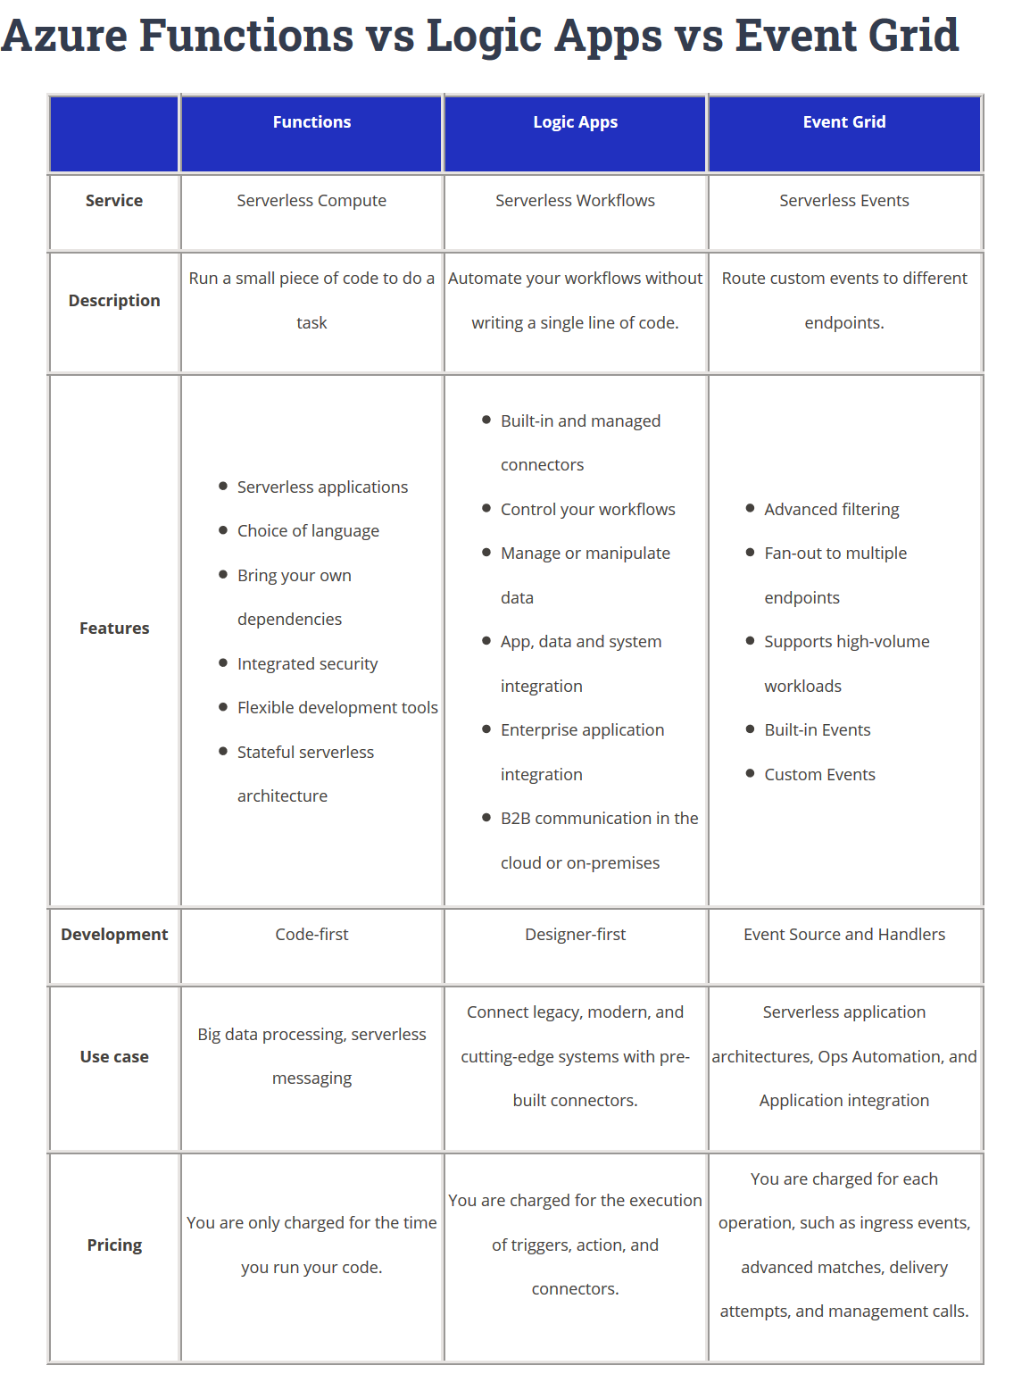

<https://tutorialsdojo.com/azure-functions-vs-logic-apps-vs-event-grid/>

# Notification Hub

<https://azure.microsoft.com/en-us/services/notification-hubs/>

Azure Notification Hubs provide an easy-to-use and scaled-out push engine that enables you to send notifications to any platform (iOS, Android, Windows, etc.) from any back-end (cloud or on-premises). Notification Hubs works great for both enterprise and consumer scenarios. Here are a few example scenarios:

* Send breaking news notifications to millions with low latency.
* Send location-based coupons to interested user segments.
* Send event-related notifications to users or groups for media/sports/finance/gaming applications.
* Push promotional contents to applications to engage and market to customers.
* Notify users of enterprise events such as new messages and work items.
* Send codes for multi-factor authentication.

# SendGrid or Mailjet

<https://docs.microsoft.com/en-us/azure/active-directory-b2c/custom-email-sendgrid>

Custom email verification requires the use of a third-party email provider like [SendGrid](https://sendgrid.com), [Mailjet](https://Mailjet.com), or [SparkPost](https://sparkpost.com), a custom REST API, or any HTTP-based email provider (including your own).

# Azure Data Factory

<https://docs.microsoft.com/en-us/azure/data-factory/introduction>

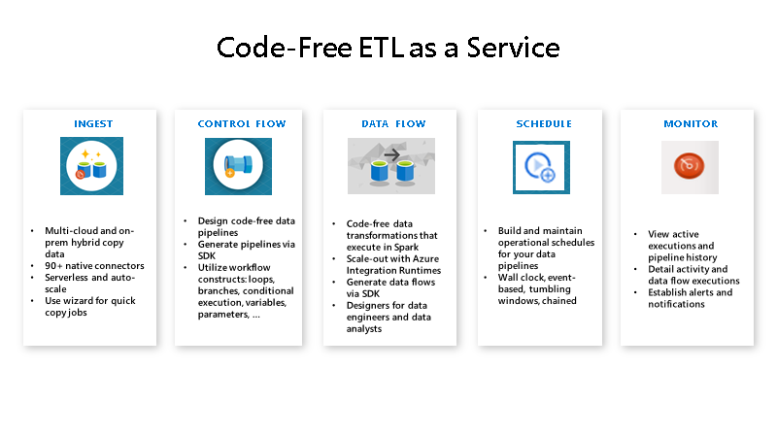

## Self-hosted integration runtime

<https://docs.microsoft.com/en-us/azure/data-factory/create-self-hosted-integration-runtime>

The Integration Runtime (IR) is the compute infrastructure used by Azure Data Factory to provide the following data integration capabilities across different network environments:

* **Data Flow**: Execute a [Data Flow](https://docs.microsoft.com/en-us/azure/data-factory/concepts-data-flow-overview) in managed Azure compute environment.
* **Data movement**: Copy data across data stores in public network and data stores in private network (on-premises or virtual private network). It provides support for built-in connectors, format conversion, column mapping, and performant and scalable data transfer.
* **Activity dispatch**: Dispatch and monitor transformation activities running on a variety of compute services such as Azure Databricks, Azure HDInsight, Azure Machine Learning, Azure SQL Database, SQL Server, and more.
* **SSIS package execution**: Natively execute SQL Server Integration Services (SSIS) packages in a managed Azure compute environment.

The following table describes the capabilities and network support for each of the integration runtime types:

|  |  |  |
| --- | --- | --- |
| Integration runtime types | | |
| **IR type** | **Public network** | **Private network** |
| Azure | Data Flow Data movement Activity dispatch | Data Flow Data movement Activity dispatch |
| Self-hosted | Data movement Activity dispatch | Data movement Activity dispatch |
| Azure-SSIS | SSIS package execution | SSIS package execution |

# API Management (API gateway service)

<https://docs.microsoft.com/en-us/azure/api-management/api-management-key-concepts>

This is very well integrated with Application insights.

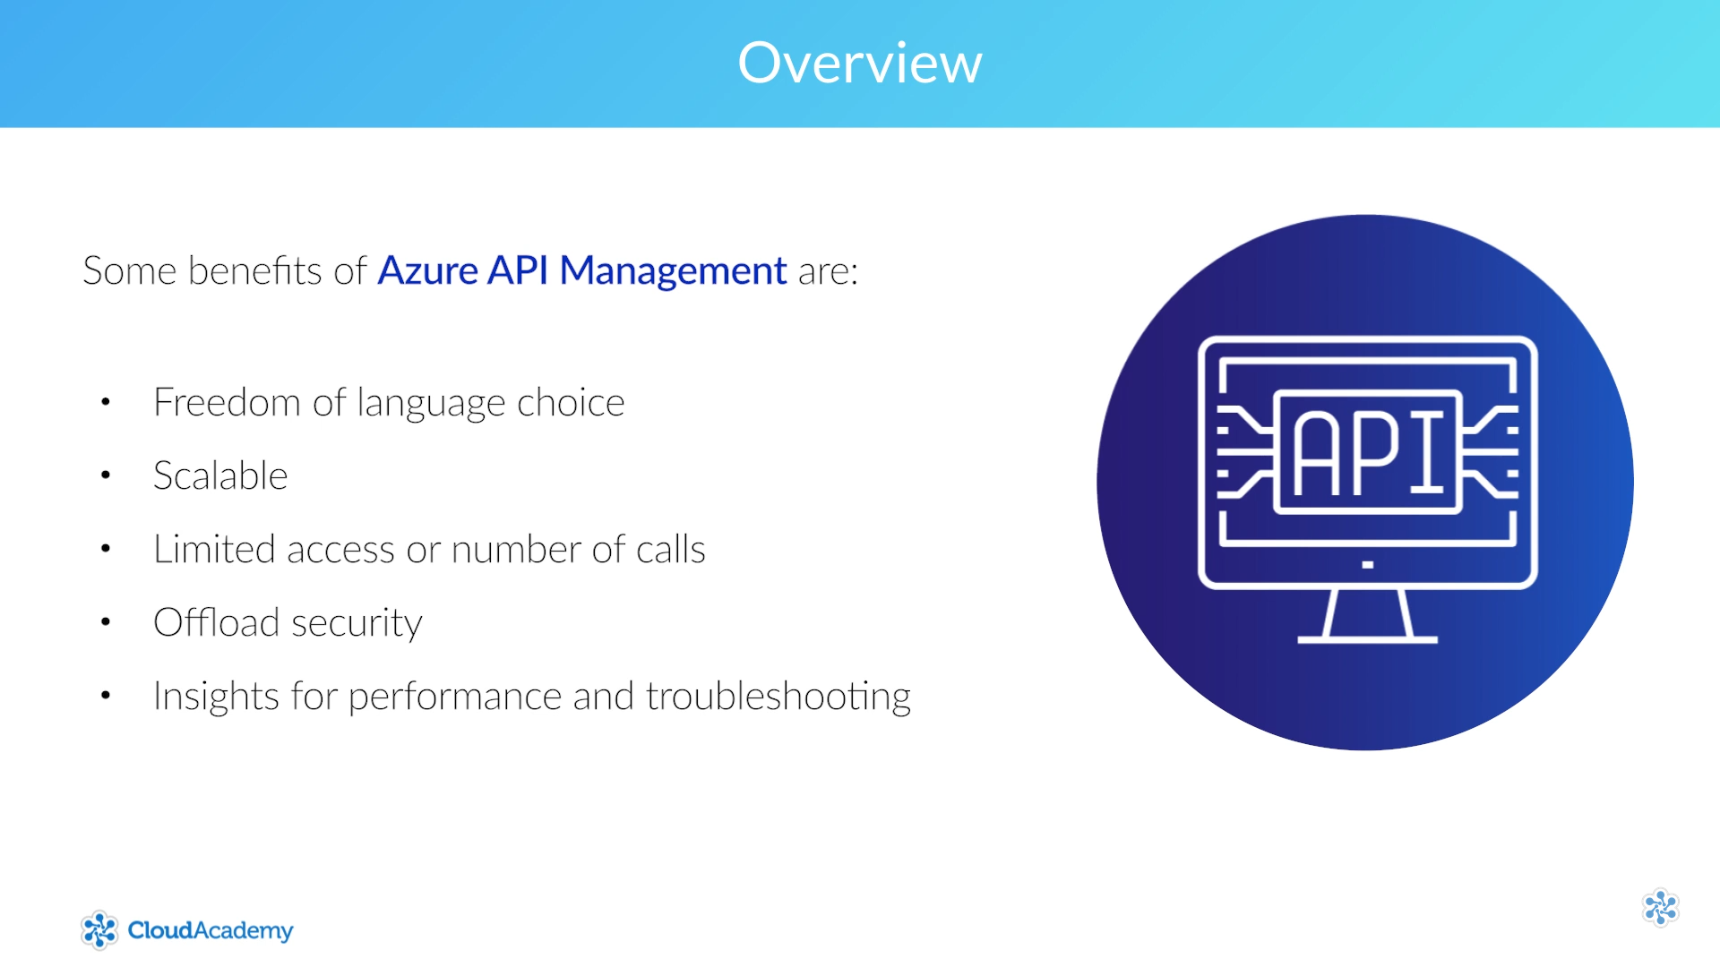

## Pricing

